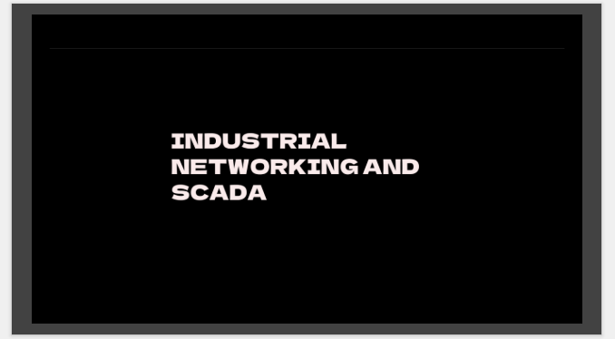

Good morning everyone.
Today I am going to present a topic which is very important for almost every automation and SCADA project — Networking.
The main objective of today's session is not just to understand what an IP address or a switch is. We will try to understand how networking actually works inside an industrial environment, especially a hydro power plant SCADA system.
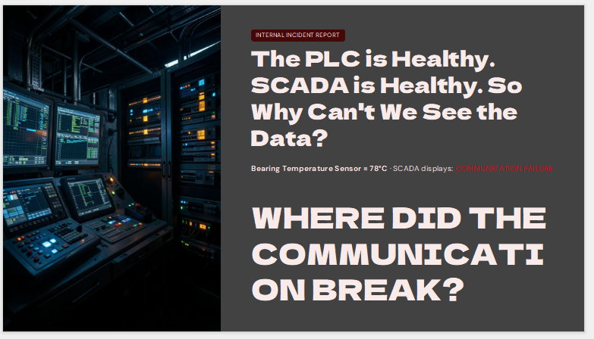

So let's start with a real troubleshooting situation.
Suppose our bearing temperature sensor is actually reading 78 degrees. PLC is healthy. SCADA server is running. HMI is running. But the operator sees Communication Failure.
Now my question is: Where exactly did the 78°C disappear?
Ask the room: If you receive this complaint from the control room, what will you check first?
Let people answer: PLC, SCADA, cable, ping, switch, firewall, IP, driver, Modbus, OPC.
Then say: Excellent. And that's exactly why networking knowledge is important. We shouldn't randomly check everything. We should be able to trace the data path and identify exactly where it stopped.

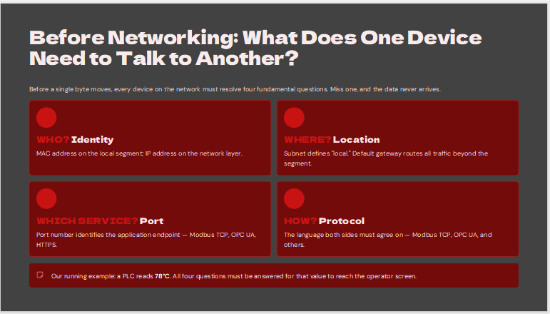

“Before networking , devices need to agree on some basic things.
I like to think of it as four simple questions.”

1. WHO? Identify with whom i have to communicate
Who am I communicating with? In networking, at the local Ethernet level we have the MAC address. At the IP level we have the IP address.
So, for example, if our PLC is 192.168.10.10, SCADA needs to know that this is the device it is supposed to communicate with.”
2. WHERE? Where is that device located
I know the IP. But is that device in my own network or somewhere else? This is where subnet mask and default gateway become important.
PLC
192.168.10.20
↓
SCADA
192.168.10.100
Same subnet → direct/local communication.
PLC
192.168.10.20
↓
Router/Gateway
↓
SCADA
192.168.20.100
Now routing becomes relevant.
3. WHICH SERVICE? Or we can say that port
IP tells me which machine. The port tells me which service on that machine.
Modbus TCP → 502
OPC UA → 4840
HTTPS → 443
Ask: Suppose I can ping the PLC but port 502 is blocked. What happens? Answer: Ping works, but Modbus communication fails.
4. HOW? Now at last
Both sides must speak the same language. If the PLC is speaking Modbus TCP and my SCADA driver expects something else, communication doesn't magically happen.

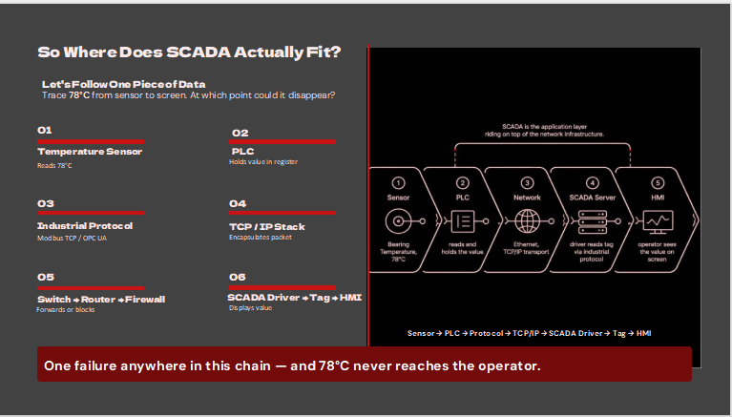

“This is probably the most important slide for understanding the complete journey.
Let's forget about networking terminology for a moment and just follow our 78 degrees.”
1. Sensor
“First, the temperature sensor measures the bearing temperature.
Let's say it is 78°C.”
2. PLC
“That signal reaches the PLC.
The PLC processes it and stores the value in a register or PLC tag.”
3. Industrial Protocol
“Now SCADA needs to retrieve that value.
The PLC may expose it through Modbus TCP, OPC UA, or another industrial protocol.”
4. TCP/IP
“That communication is then carried through the TCP/IP stack.”
5. Network infrastructure
“The packet travels through the network infrastructure — potentially through a switch, router, or firewall.”
6. SCADA driver
“At the SCADA side, the driver receives the communication and interprets the protocol.”
7. SCADA tag
“The driver maps the value to the appropriate SCADA tag.”
8. HMI
“And finally, the operator sees something like:
Bearing Temperature — 78°C.”
Key point
“Now imagine anything in this chain fails.”
“The sensor can be healthy.”
“The PLC can be healthy.”
“The SCADA application can be healthy.”
“But the operator can still see communication failure.”
“Because the complete communication chain has to work.”
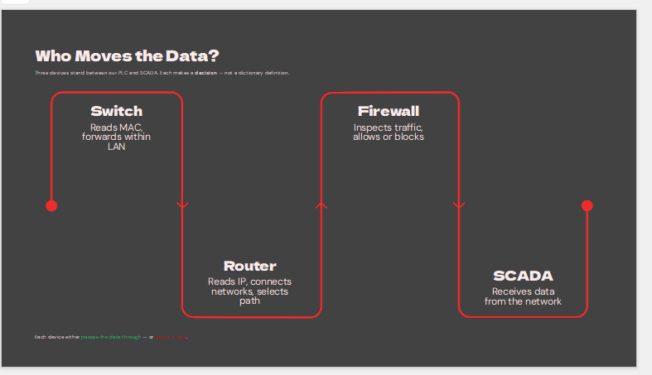

“So now the question is — who is actually moving this data through the network?”
“There are a few important devices sitting between our PLC and SCADA.
And each one has a different job.”

Switch
“First, the switch.
If the PLC and SCADA are communicating within the same LAN, the switch is responsible for forwarding the Ethernet traffic.
It primarily works with MAC addresses.”
Practical example
“For example, imagine we have ten PLCs connected to one managed switch.
PLC number 1 sends data to the SCADA server.
The switch knows which port the destination device is connected to and forwards the traffic accordingly.”

Router
“Now suppose our PLC network is different from our SCADA server network.
For example:
PLC network — 192.168.10.x
SCADA network — 192.168.20.x
Now we need something to connect those networks.
That's where the router comes in.”

Firewall
“Then we have the firewall.
The firewall is basically asking:
Who is connecting? Where are they connecting? Which port are they using? And is that traffic allowed?”
Practical example
“So imagine everything is correctly configured, but TCP port 502 is blocked.
The PLC is healthy.
SCADA is healthy.
The cable is connected.
You might even be able to ping the PLC.
But Modbus communication still won't work.”
Strong statement
“So every network device can either allow our data to continue — or stop it.”
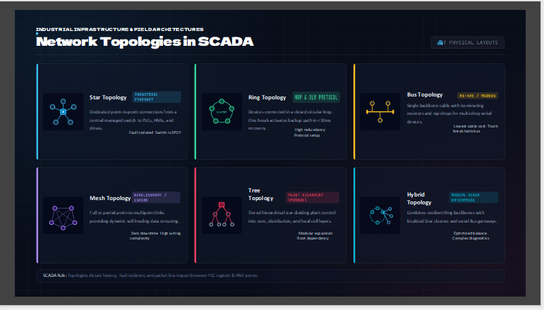

“Now let's move from individual devices to the overall network architecture.
The topology tells us how the devices are physically or logically connected.”

Star
“The first one is star topology.
This is very common with Ethernet networks.
Devices such as PLCs, HMIs and drives connect back to a central switch.”
Practical example
“For example, inside a control panel we might have:
PLC,
HMI,
VFD,
engineering laptop,
all connected to one managed switch.”
“It's simple and easy to troubleshoot.
But if that central switch fails, several devices can disappear at the same time.”

Ring
“In a ring topology, devices form a circular path.
The advantage is redundancy.
If one communication link is broken, traffic can potentially travel in the other direction.”
Practical example
“Imagine several hydro plant panels connected through fiber.
If one fiber section is damaged, a redundant ring can keep communication alive through the alternative path.”

Bus
“Bus topology uses a shared backbone.
It was especially common in traditional serial industrial networks.
The advantage is lower cabling requirements, but a failure in the main trunk can affect the entire segment.”

Mesh
“Mesh provides multiple communication paths.
That gives us high redundancy, but the network becomes more complex to design and diagnose.”

Tree
“Tree topology is hierarchical.
We can have a core network, distribution level and then local control networks.”

Hybrid
“And in actual industrial plants, we often don't have one pure topology.
We might have a ring backbone, star connections inside individual panels, and serial bus networks connected through gateways.
That's why hybrid architectures are very common.”
Practical conclusion
“So topology isn't just a diagram for documentation.”
“It directly affects what happens when something fails.”

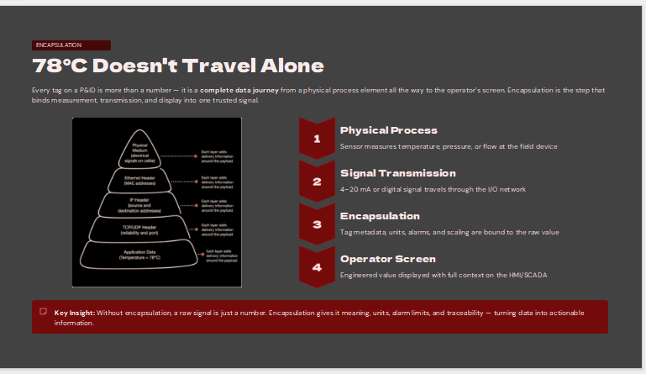

“Now let's take our same example — bearing temperature = 78°C.
I want you to imagine that this 78°C value is a package that has to travel from our PLC to the SCADA server.
The 78°C doesn't travel alone.
As the data moves down through the networking layers, different information is added to it so that the network knows where it came from, where it needs to go, and how it should be delivered.”

Start at the application level
“At the application level, our actual information is:
Bearing Temperature = 78°C
This is the information our SCADA application actually cares about.”
For example:
Bearing Temperature = 78°C
“But the network can't simply throw this number onto the cable. It needs more information.”

Transport layer — TCP
“When TCP is being used, the transport layer adds information such as source and destination ports.
For example, if we're communicating using Modbus TCP, the destination port is commonly 502.
Now the network knows which application service should receive this data.”
You can write:
78°C
+
TCP information
+
Destination Port: 502
Then say:
“So now it's not just 78°C anymore. We have the data plus information about the communication service.”

Network layer — IP
“Next comes the IP layer.
Now we need to tell the network where this data is going.
So IP addresses are added.”
Example:
Source IP → 10.10.10.20 PLC
Destination IP → 10.10.10.100 SCADA
Then say:
“Now the network knows:
Who sent it?
Where should it go?”

Data Link layer — Ethernet
“Then we go one level further down to the Ethernet layer.
Here, information such as the source and destination MAC addresses is used for delivery on the local network.”
You can show:
Source MAC → PLC
Destination MAC → SCADA / next-hop device
Then:
“So now the switch can look at the Ethernet frame and decide where to forward it.”

Physical layer
“Finally, the data is converted into signals that can actually travel through the physical medium — for example, electrical signals over copper, light over fiber, or radio signals in a wireless network.”
Then point to your original 78°C:
“So remember, the actual information is still:
Bearing Temperature = 78°C
But now it has been wrapped with the information required for communication.”
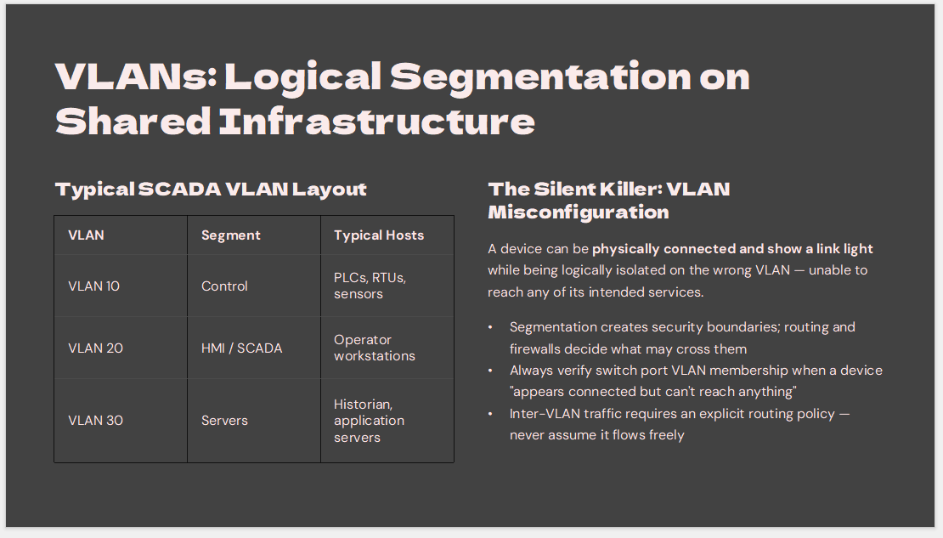
“Now imagine our hydro plant has one big managed switch.
We have PLCs, HMIs, SCADA computers, historians and servers.
All of these devices need networking.
My question is:
Should we put all of these devices into one single network?”
Pause and let them answer.
Then:
“Technically, we could create one large network, but in an industrial environment we usually want to separate different types of devices logically.
This is where VLANs come in.”

🏭 Explain VLAN with a simple analogy
“Think about our office building.
We may have different departments — HR, Finance, Engineering and IT.
They can all be inside the same building, but we don't necessarily want everyone to be in the same logical group.
A VLAN does something similar for a network.
One physical network infrastructure can be divided into multiple logical networks.”
Then point to the slide.

🔹 VLAN 10 — Control
“For example, we can create VLAN 10 for the control network.
This could contain devices such as:
PLCs, RTUs and other control-related devices.”
Point to VLAN 10.
“So our PLCs can logically belong to this control network.”
Example:
VLAN 10 — CONTROL

PLC 1
PLC 2
RTU
Control devices

🔹 VLAN 20 — HMI / SCADA
“Then we can have VLAN 20 for HMI and SCADA systems.
So our operator stations and SCADA workstations belong to another logical network.”
Example:
VLAN 20 — HMI / SCADA

HMI 1
HMI 2
SCADA Workstation
Engineering Station

🔹 VLAN 30 — Servers
“And we can have another VLAN for our servers.
For example:
Historian server,
application server,
database server,
and other SCADA-related servers.”
VLAN 30 — SERVERS

Historian
Database
Application Server
Then point to the complete diagram:
MANAGED SWITCH
|
┌──────────────┼──────────────┐
↓ ↓ ↓
VLAN 10 VLAN 20 VLAN 30
CONTROL HMI / SCADA SERVERS
| | |
PLC HMI Historian
RTU SCADA PC Database

🎯 Now explain the important concept
“Now here's the important thing.
These devices may be connected to the same physical switch, but logically they are separated into different VLANs.”
This is the sentence I would emphasize.
“So VLAN is basically giving us logical separation over shared physical network infrastructure.”

🚨 The practical failure scenario
Suppose we have a PLC connected to a switch.
The cable is connected and the switch light is green.
So we know the PLC is physically connected.
But imagine the PLC is connected to the wrong group in the network.
Then SCADA may still not be able to communicate with it.
This is one of the problems VLANs help us manage.
So remember:
Green light only tells us that the cable is connected. It doesn't tell us that the PLC can communicate with SCADA.”

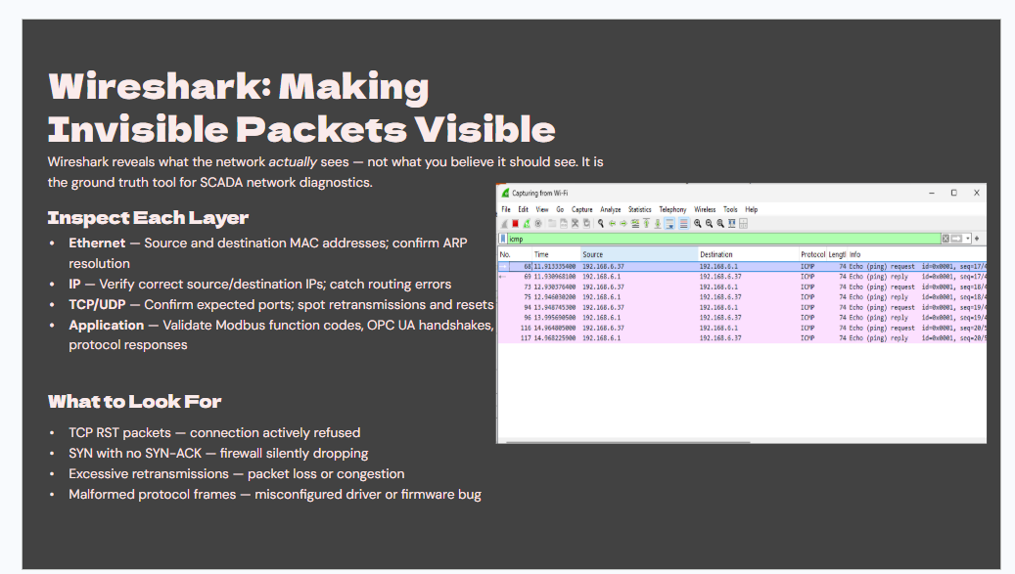

“Now let's talk about Wireshark.
Wireshark is basically a tool that allows us to see what is actually happening inside the network.
Normally, when we look at SCADA, we only see something like:
PLC → SCADA → 78°C
But if the SCADA is not receiving the value, we need to know where the communication is actually failing.
We can open Wireshark and capture the network traffic.
First, we can check the Ethernet layer.
Here we can see the source and destination MAC addresses.
Then we check the IP layer.
For example, we can confirm whether the PLC IP is actually communicating with the SCADA server IP.
Then we check TCP.
For example, Modbus TCP normally uses port 502.
So if we see the connection being established, we know that the TCP communication is working.
Finally, we can look at the application layer and check whether the actual Modbus communication and responses are coming correctly.
For example:
PLC → 78°C → Modbus packet → Network → SCADA
Wireshark allows us to see those packets instead of guessing.
There are also some very useful signs.
If we see TCP RST, it means the connection was actively refused.
If we see SYN but no SYN-ACK, something may be blocking the connection, such as a firewall.
If we see many retransmissions, it can indicate packet loss or network problems.
So the simple idea is:
Ping tells us that the device is reachable.
Wireshark tells us what is actually happening to the packets.
That is why Wireshark is very useful when troubleshooting a SCADA network.”
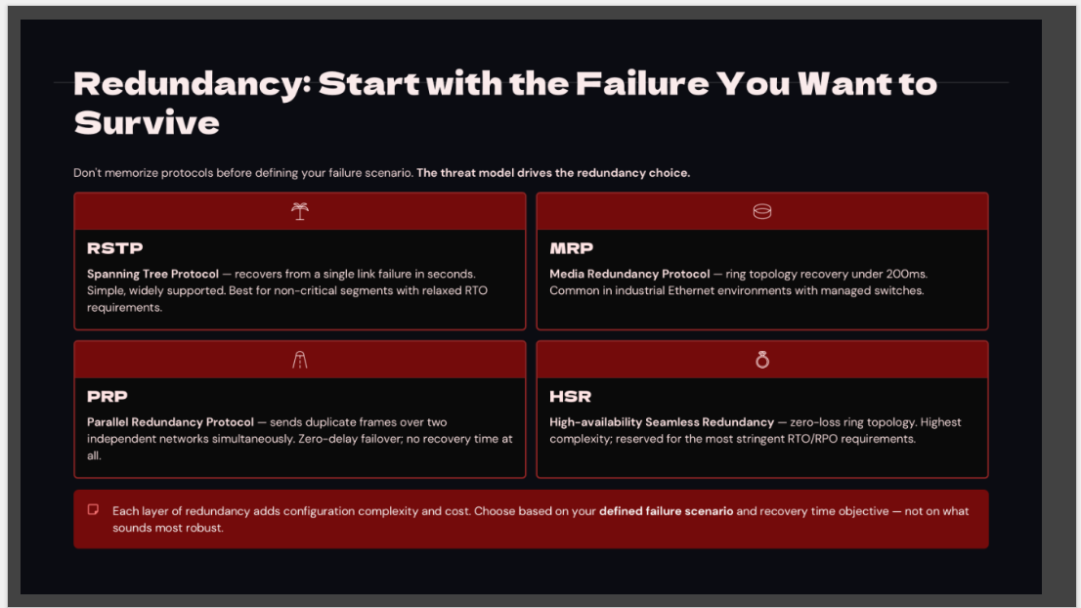

Redundancy — Opening
“Now let's talk about network redundancy.
First, we ask one simple question: what failure do we want to survive?
For example, if one network cable breaks, we still want our PLC and SCADA to communicate.
That's why we use redundancy.”

RSTP
“RSTP, or Rapid Spanning Tree Protocol, prevents network loops and keeps another path available.
If the main path fails, traffic can use the backup path.
So, RSTP means backup path with loop prevention.”

MRP
“MRP, or Media Redundancy Protocol, is used mainly for industrial Ethernet rings.
If one cable in the ring breaks, communication can continue through the other side.
So, MRP means industrial ring redundancy.”

PRP
“PRP, or Parallel Redundancy Protocol, uses two independent networks.
The same data is sent through both networks.
If one network fails, the other can still deliver the data.
So, PRP means two networks working in parallel.”

HSR
“HSR means High-availability Seamless Redundancy.
It uses a redundant ring so data can still reach the destination if one path fails.
So, HSR means seamless ring redundancy.”

DLR
“DLR means Device Level Ring.
It connects industrial devices in a ring.
If one link fails, communication can continue through the other direction.
So, DLR means redundancy at the device level.”

ERPS
“ERPS means Ethernet Ring Protection Switching.
It protects an Ethernet ring from a link failure by changing the traffic path.
So, ERPS means protection and fast recovery for an Ethernet ring.”

Connect it to Hydro SCADA
“For example, our PLC is sending a 78-degree temperature value to SCADA.
If one network cable fails, redundancy gives the data another way to reach SCADA.
So the main idea is very simple:
Something fails, but communication should continue.”

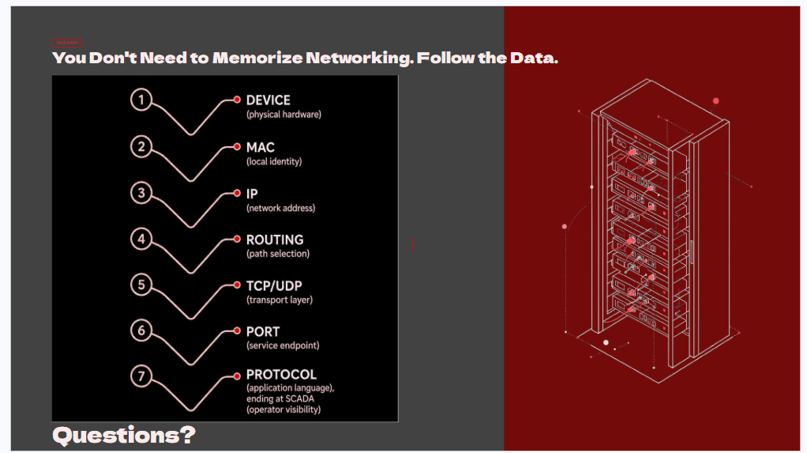

“So, let's finish with the main takeaway from this training.
You don't need to memorize every networking command or every protocol.
The most important thing is to follow the data.
For example, if our PLC has a temperature of 78°C, we can ask:
Where did the value start?
Sensor → PLC → Protocol → TCP/IP → Switch → Firewall → SCADA Driver → Tag → HMI
If the operator cannot see 78°C, we simply follow this path and find where the communication stopped.
That is the main way we should think about networking in a SCADA system.
So instead of just asking:
‘Why is SCADA not working?’
we should ask:
‘Where did the data stop?’
Once we follow the data step by step, troubleshooting becomes much easier.
That's the main takeaway: You don't need to memorize networking. Follow the data.
Thank you everyone.
Any questions?”

